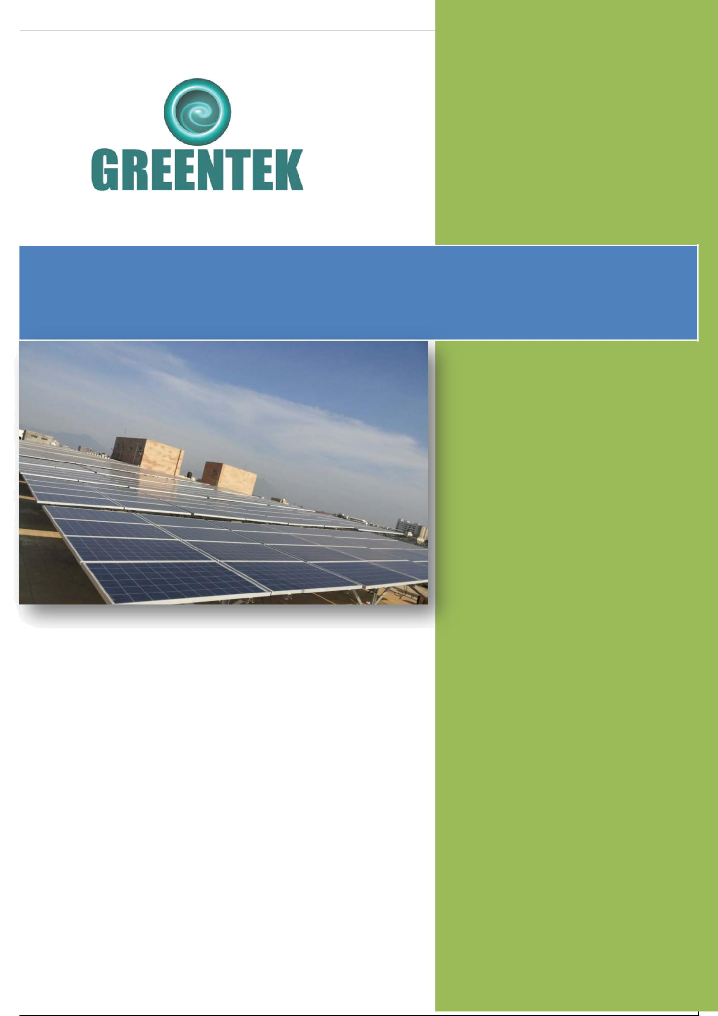
Greentek India Private Limited

Proposal for 5KWp Solar On-Grid Power Plant System

M/s. GREENTEK INDIA PVT LTD
Plot # 8, Lepakshi colony
West Marredpally, Secunderabad -500026
Tel: 040-27807145 / 040-65198519 |  | To,  Power Factor Systems  Chennai-77
Mr. Sandhosh Kumar
Regional Manager
Mob: +91-90031 32081
E-mail: southsales@greentekindia.co.in
Solar Proposal:
GIPL/SPV/SECI/TN/005/2017-18
Dated: 28/06/2017

Greentek India Pvt. Ltd.



Introduction, Vision & Mission of Greentek India Pvt Ltd

Greentek India Pvt Ltd is incorporated in the year 2007 and expertise in all renewable energy systems. Joint ventured with many reputed companies throughout the India and having the best technical partners and supplier in their class throughout India

GIPL is an ISO 9001:2008 certified Company based in Hyderabad as one of the leading manufacturers of Solar Photo Voltaic Modules (SPV) in the Country. We are manufacturing modules in the range of 37W to 300W. Thus, our Module production line is geared to produce panels of any custom size or wattage having Certifications/Approvals from MNRE, IEC 61215, IEC 61701, IEC 61730.

GIPL is having strong presence in the field of Renewable Energy and provides complete turnkey solar EPC solutions. We have a team of highly skilled solar engineers to design and construct you solar project. GIPL offers Advisory Services, Engineering, Procurement & Construction (EPC) Services and Operation & Maintenance Services Solar Power Projects ranges KWp to MWp scale to domestic, industrial, commercial and government entities.

To become one of the leading renewable energy equipments and turnkey solution provider we always aim at one step ahead in the development of innovative and competitive solutions for the production and management of electrical power through Solar PV systems. Served & serving many esteemed organizations and individuals in India.

Solar Photovoltaic:

- Grid connected or Utility scale Solar Power Projects.

- Off-grid SPV Power Packs.

- Rooftop Solar Power Projects (Standalone & Grid-tied).

- Other Solar application

GIPL is a registered Solar PV Systems integrator in New and Renewable Energy Development Corporation of Andhra Pradesh (NREDCAP) & TNREDC.

GIPL tries not just to meet our customer’s expectations; strive to exceed the customer’s expectations. Every time, measure its success by its customer’s trust and confidence in us. We always work with principle to provide up to date technology, the best quality equipment, error less workmanship and on time service to its clients.

Greentek India Pvt. Ltd. www.greentekindia.co.in

GIPL will work to make sure that your project meets all required accreditation and certifications in compliance with ministerial and international standards. We have partners in different segments of the solar business to make sure that we get the best products/services at the best price.

We are herewith attaching our quote for 5KWp On-Grid SPV system as required by you for your consideration and placement of order.

Greentek India Pvt. Ltd. www.greentekindia.co.in

Proposal for 5 kWp Grid Tied Captive Solar PV Power Plant

Customer details:

Name: | Power Factor System
Address: | Otteri- Chennai
Contact Person: | Mr.
Mobile: | 98401 98416
Email: | powerfactorsystems@yahoo.co.in
Site details:

Address: | Thirumangalam, Chennai
Longitude: | 80.1923627° E
Latitude: | 13.0348826° N
Rooftop / ground mounted: | Rooftop – mounted on the building’s rooftop
Type of roof / soil: | Flat Terrace
Availability of water: | Yes
Shading: | Area selected is net of shade from building
Load details:

Connected load: | N.A.
Contracted demand: | N.A.
Maximum demand: | N.A.
Type of connection: | Grid
Phases: | 3 Phase
Supply sub-station | NA
Electricity consumed
Existing power backup:

DG / Inverter: | Inverter
Capacity:
Connected load:
Proposed system:

Type of system: | Grid tied system of 5 kWp capacity with solar Priority Requires an additional source of power –Grid or DG for functioning (it cannot run in standalone mode)

 | Module mounting: | Fixed tilt, mounted on the sloping factory roof. Kindly note that when the factory roof is prepared, we will guide you through our requirements for providing access to the roof. Kindly note that:   The roof prepared should have a load bearing  capacity of at least 40-50 kgs/ sq metre   The area required for 5 kWp will be about  10 sq metres
 | Inverter capacity: | High efficiency, inverters suitable for 5 kWp Solar Power Plant
 | Battery bank capacity: | NIL
 | Power generation: | We will guarantee 7.0 KWh/year Respectively for 5KWp Systems subject to grid availability and assuming 300 working/ consuming days
 | Degradation: | 1% p.a.
 | Project life: | 25 years
 | Infrastructure requirement:
 | Rooftop space / land  requirement: | We have assumed that the terrace is flat and available for construction. Any modifications to the terrace space to suit the client requirements will be charged extra.
 | Electricity: | Electricity required during the construction of the plant is in the Client’s scope
 | Water: | Water required during the construction of the plant is in the Client’s scope
Project cost:

System cost Before Subsidy.  5 KWp | Rs. 3,25,000/- (Rupees Three Lakhs Twenty Five Thousands Only)
Subsidy of 30% | NIL
Net Cost After Subsidy | Rs. 3,25,000/- (Rupees Three Lakhs Twenty Five Thousands Only)

 | AMC & remote monitoring: | 2% of the Project Cost per annum  * Panel cleaning will be in the Client’s scope
 | AMC escalation: | 5% p.a.
 | Project completion timeline: | 3 weeks from receipt of advance payment.
 | Commercial terms:
 | Price basis: | FOR site
 | Validity: | 30 days from submission of the offer.
 | Taxes & duties: | Inclusive of VAT / CST @ 5%, Service tax@12.36%
 | Placement of order: | Purchase Order will be placed on the Gross value of the System (including subsidy) Purchaser order should be placed upon us along with the advance payment as mentioned in the terms of Payment. Purchase order shall be considered effective from the date of receipt of advance payment along with commercial terms acceptable to us No binding contract shall be deemed to have been effected by the acceptance on the part of the purchaser of a quotation or offer made by us until such contracts have been confirmed in writing through order acceptance by us Orders once placed with us cannot be cancelled by purchaser on any account whatsoever
 | Delivery schedule: | As per project timeline
 | Payment terms: | As a percentage of the Net Value of System  - 100% advance along with PO
 | Warranty: | - 25 years for SPV modules
 |  | - 5 years for balance of system

 | Project benefits:
 | Power savings: | The system generates appx. 90.00 MWh of power during its lifetime of 25 years for 3KWp Systems respectively.
 | Reduction in carbon emission: | Installing a 5 kWp system is equivalent to planting 300 mature trees respectively

Annexure – I
System specs

Item | Details | Make | 5KWp
SPV Modules | Mono/Poly crystalline  silicon modules | Greentek India Pvt Ltd | 325Wp x 15  Nos
Module mounting | MS galvanized | Reputed makes | 5 kWp
structure | MS galvanized | Reputed makes
Inverter | High efficiency 3-Phase Grid Tied Solar String Inverter | Growatt/Polycab / Equivalent | Suitable for 5 kWp
Cables | Cu / Al - BIS standard | Polycab / KEI | As per site
LT Switchgear | BIS standard | ABB / Legrand / L&T/ Schneider | As Required
Other hardware &  electricals (incl. earthing & lightning protection) | BIS standard | Reputed makes | 1 set
Installation | MNRE standard | Greentek India Pvt Ltd | Included
Freight | For Site
System Requirements and Design will be as per MNRE / SECI project installation policies.

Addendum1 - Operation Schematic of Grid Connected Solar

Scenario I
 |  |  |  |  |  | For a load of 15 kW, 10 kW solar
Grid: Available |  |  |  |  |  | power which is available is drawn
 |  |  |  |  |  | on priority with the balance 5 kW
Solar: Available (10kW)
 |  |  |  |  |  | being supplied from the grid.
Load: 15 kW
 |  |  |  |  | 5 kW
 |  | Grid |  |  | 5 kW
 |  |  |  |  | 10 kW | Load | 15 kW
 |  | Solar |  |  | 10 kW | Load | 15 kW
 |  | DG |  |  | 0 kW
Scenario II |  |  |  |  |  | For a load of 15 kW, 10 kW solar
Grid: Not Available |  |  |  |  |  | power which is available is drawn
 |  |  |  |  |  | on priority with the balance 5 kW
Solar: Available (10kW)
 |  |  |  |  |  | being supplied from the diesel
Load: 15 kW
 |  |  |  |  |  |  | generator.
DG: 5 kW |  |  |  |  |  |  | generator.
 |  |  |  |  | 0 kW
 |  | Grid |  |  | 0 kW
 |  |  |  |  | 10 kW | Load | 15 kW
 |  | Solar |  |  | 10 kW | Load | 15 kW
 |  | DG |  |  | 5 kW
Scenario III |  |  |  |  |  | Although solar power is available,
Grid: Not Available |  |  |  |  |  | the loads will not run due to
 |  |  |  |  |  | unavailability of reference power.
Solar: Available
 |  |  |  |  |  |  | (Grid Power / DG)
DG: Not Available |  |  |  |  |  |  | (Grid Power / DG)
 |  |  |  |  | 0 kW
 |  | Grid |  |  | 0 kW
 |  |  |  |  | 0 kW | Load | 0 kW
 |  | Solar |  |  | 0 kW | Load | 0 kW
 |  |  |  |  |  |  | No power supply to
 |  | DG |  |  | 0 kW |  | the loads
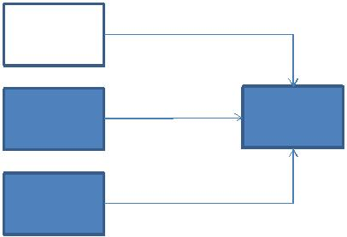
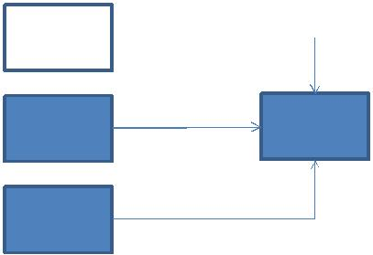
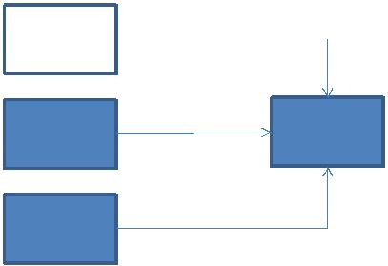

Return on Investment

Item | Unit | Value
System Size | KWp | 5
System cost | Rs | 3,25,000.00
Subsidy claim On the system | Rs | 0.00
Net cost after Depreciation | Rs | 3,25,000.00
Net cost to client | Rs | 3,25,000.00
Avg. solar units generated | Units / | 6000
Avg. solar units generated | Years | 6000
Variable Cost of Power (Assuming 100 % EBusage @INR 10/ unit) | Rs/ unit | 10
Avg. savings per year | Rs/ year | 60,000.00
Assumed increase in EB+DG tariff | % | 5%
Payback period | Years | 5
Project life | Years | 25
Savings of project life | Rs | 15,00,000.00
Projected Simple IRR | % | 35.99%
Rooftop area required | sqft | 240
Generation Cost Per Unit On System Cost Before Subsidy(On Total Units For 25years) | Rs/Unit | 1.84
Generation Cost Per Unit On System Cost After Subsidy(On Total Units For 25years) | Rs/Unit | 1.288
Generation Cost Per Unit On System Cost After Subsidy and Tax AD(On Total Units For 25years) | Rs/Unit | 1.288


NASA Surface meteorology and Solar Energy: RETScreen Data

Latitude 13.035 / Longitude 80.192 was chosen.
 | Unit | Climate data location
Latitude | °N | 13.035
Longitude | °E | 80.192
Elevation | m | 59
Heating design temperature | °C | 22.17
Cooling design temperature | °C | 33.78
Earth temperature amplitude | °C | 8.47
Frost days at site | day | 0

Month | Air temperature | Relative humidity | Daily solar radiation – horizontal | Atmospheric pressure | Wind speed | Earth temperature | Heating degree-days | Cooling degree-days
 | °C | % | kWh/m²/d | kPa | m/s | °C | °C-d | °C-d
January | 25.1 | 66.50% | 4.93 | 100.7 | 3.9 | 27 | 0 | 468
February | 26.1 | 64.00% | 5.89 | 100.5 | 3.5 | 29.2 | 0 | 457
March | 27.5 | 63.00% | 6.64 | 100.4 | 3.5 | 31.4 | 0 | 547
April | 28.3 | 70.10% | 6.72 | 100.1 | 3.5 | 31.7 | 0 | 553
May | 29.7 | 68.60% | 6.12 | 99.8 | 3.8 | 32.2 | 0 | 615
June | 30.1 | 65.00% | 5.24 | 99.7 | 4.4 | 31.2 | 0 | 606
July | 29.5 | 66.40% | 4.73 | 99.8 | 4.2 | 30.4 | 0 | 604
August | 29.4 | 66.70% | 4.8 | 99.8 | 4.1 | 30.5 | 0 | 601
September | 28.5 | 71.70% | 5.01 | 100 | 3 | 30.1 | 0 | 556
October | 27 | 76.90% | 4.42 | 100.2 | 2.8 | 28.3 | 0 | 530
November | 26.1 | 74.20% | 4.06 | 100.5 | 3.6 | 26.8 | 0 | 485
December | 25.5 | 68.20% | 4.24 | 100.7 | 4.2 | 26.3 | 0 | 482
Annual | 27.7 | 68.40% | 5.23 | 100.2 | 3.7 | 29.6 | 0 | 6504
Measured at (m) |  |  |  |  | 10 | 0

Technology Selection and Key components

Photovoltaic (PV) is the technical word for solar panels that create electricity. Photovoltaic material, most commonly utilizing highly purified silicon, converts sunlight directly into electricity. When sunlight strikes the material, electrons are dislodged, creating an electrical current, which can be captured and harnessed. The photovoltaic materials can be several individual solar cells or a single thin layer, which make up a larger solar panel.

Solar Photovoltaic Technologies:

Over the past three decades SPV technology has shown impressive growth towards technological and economic maturity. The major SPV technologies based on materials used are
• | Crystalline Technology

Crystalline Technology:

Crystalline Silicon cell technology continues to dominate and forms about 90% of market share. It is the current industry leader and almost all applications use crystalline silicon based PV technology. It is ideally suited for locations with space constraints due to higher efficiency than thin-films. Crystalline Silicon (c -Si) was chosen as the first choice for solar cells, since this material formed the foundation for all advances in semiconductor technology. The technology led to development of stable solar cells with up to 18% efficiency.

Advantages:

- Highest efficiency levels (14.5% to 16%).
- Commercially most widely used among PV technologies.
- Sustained dominance in PV industry for over 25 years.
- Higher current / lower voltage features enable easier system design.
- Project implementation can be done in stages starting with module assembly and backward integration to wafer fabrication stage or the other way from wafer to cell to module
- Performance guarantee for c-Si modules is generally in excess of 25 years

Rationale for choosing Crystalline Technology

Owing to their capability to withstand more stress and their robust and study nature to be generating better than warranted results

Solar Photovoltaic module:

High power and/or High Efficiency Poly Crystalline Modules shall be used in the Solar Photo-Voltaic panels. Peak power rating shall not be less than 230 Wp for crystalline technology module.
To connect the solar module prefabricated interconnection cable shall be provided. Module shall be made of high transitivity glass front surface giving high encapsulation gain and hot butyl rubber edge sealant for module protection and mechanical support. All materials used shall have a proven history of reliable and stable operation in external applications.

Greentek India Pvt. Ltd. www.greentekindia.co.in

Technical Requirements of PV Module:

The following are some of the technical measures required to ensure quality of the PV modules used in grid solar power projects.

PV Module Qualification

The PV modules must qualify to the latest edition of IEC 61215 qualification and the manufacturing facility has to be ISO 9001 certified.

In addition, PV modules must qualify to IEC 61730 for safety qualification testing. For the PV Modules to be used in a highly corrosive atmosphere throughout their lifetime, they must qualify to IEC 61701. Authorized Test Centers
The PV modules are tested and approved by the IEC authorized test centers

PV Warranty of modules used in grid solar power plants must be warranted for output wattage, which should not be less than 90% at the end of 10 years and 80% at the end of 25 years.

INVERTER

Solar PV modules produce DC power which has to be converted into AC to export to the grid. The same can be done using inverters.

The excellent productivity level and system availability of this inverter series offer a unique solution designed to optimize the ROI (return on investment) of medium to large-scale PV installation. The modular approach guarantees increased energy efficiency, available in MPPT configuration for minimum mismatching losses.

Excellent reliability is achieved by the application of intelligent monitoring functions and top-quality components, including faster, safer, fault-free connections. Advanced grid management features ensure optimized system operability in a wide range of conditions throughout the world.

Modular design ensuring highest system availability Max Efficiency: 98.6% Advanced grid management features like LVRT, HVRT, Power factor regulation etc. DC Load Break disconnect for each inverter module to provide isolation from the solar array

Module Mounting Structure

Our PV modules mounting structures are made with Mild Steel /hot dipped Galvanized (at least 120 micron) Iron for holding the PV modules. The legs of the structure shall be fixed and grouted in the RCC foundation column. The foundation will support SPV modules with structure at a given orientation, absorb and transfer the mechanical loads to the ground properly and withstands maximum wind speeds up to 150 km/hr. All fasteners are made of good quality Mild Steel with HDG/Stainless Steel. The structures are designed to allow easy replacement of any module. The minimum clearance of the lowest part of the module structure and the developed ground level will be more than 500 mm. The array structure is designed in such a way that it will occupy minimum space without sacrificing the output from the SPV panels. Structure drawings are below

Greentek India Pvt. Ltd. www.greentekindia.co.in

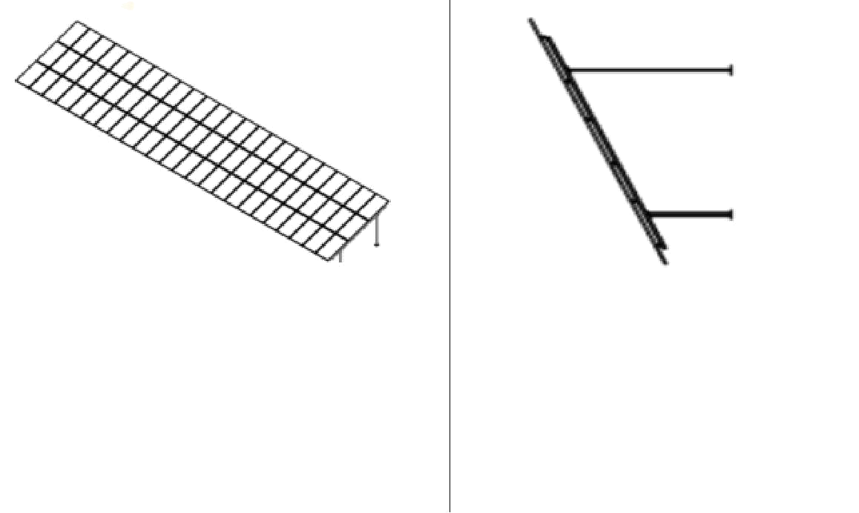

Isometric View | Side View

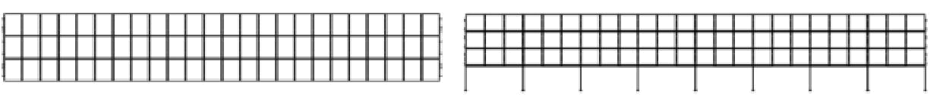

Top View | Front View

Mounting Structure

Cables and Connectors
Solar cables are extremely robust and resist high mechanical load and abrasion. High temperature resistance and excellent weatherproofing characteristics provide a long service life to the cables used in large scale projects. The connectors with high current capacity and easy mode of assembly are to be used for the connections of the power plant cables.

^{Connectors:}
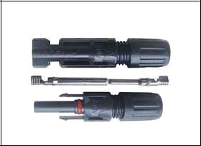
MC4 connectors with IP67 are used to inter connect the modules and to the string combiner boxes. As the connectors are IP67 they are 100% water proof and can handle temperatures more than 85⁰C


Figure 1: Male and female MC4 connectors

AC/ DC distribution boards LT panel

All distribution boards will be having MCCBs and Indicators. Energy Meters are to be interconnected through copper/Al bus bar and are to be housed in a suitable sized sheet metal, enclosure. The panel board will be grounded and for this purpose a suitable ground terminal is to be arranged. The distribution panel board is dust and vermin proof which is environmentally safe and high quality paint will be done for the panel. The distribution panel board shall be wall mounted type and of front door opening type. The Distribution panels are designed for cable entries and consist of MCB at incoming and at outgoing terminals suitable size Cu wire will be supplied and installed for interconnection of inverter.

Greentek India Pvt. Ltd. www.greentekindia.co.in

Lightning and over voltage protection

proper earth pits
The Lightning conductors shall be provided as per IS standard in order to protect the Necessary concrete foundation for holding the lighting conductor in position will be made after giving due consideration to maximum wind speed.
To Protect Entire Solar Array yard from Lightning strikes.
Lighting conductors shall be earthed through flats and connected to earth mats as per applicable Standards with earth pits.
The pits are provided with Masonry enclosure with cast iron cover plate having locking arrangement, watering pipe using charcoal and salt as per IS.
Earthling system and grounding

The complete Solar PV power Plant with all its accessories will be grounded, so that in the event of a lightning strike or utility over voltage, current will find a safe path to earth Each Solar PV array structure shall be grounded properly as per IS standard The earth conduction shall run through appropriate pipes partly buried and partly on Ththe surface of the control room building. The complete earthling system shall be mechanically & electrically connected to provide independent return path to earth Each Array structure of the SPV Yard shall be grounded properly. The array structures are to be connected to earth pits as per IS standards
The earthing for the power plant equipment shall be made as per provisions of IS. Necessary provision shall be made for bolted isolating joints of each earthing pit for periodic checking of earth resistance. The complete earthing system shall be mechanically & electrically connected to provide independent return to earth. All three phase equipment shall have proper earth connection.

Project Implementation

Manpower Requirement

The project can be divided into 3 major sections for installation purpose

1. Civil foundations for module mounting and control room construction 2. Installation of module mounting structures and Modules

3. Installation of electrical components

Packing, Transportation and Storage of equipment

The equipment will be prepared in such a manner as to protect the equipment from damage or deterioration during shipping or storage. The shipments could be exposed to heavy rains, hot sun, high humidity and sudden extreme changes of temperature. The equipment will be packed and shipped so as to protect it from all such conditions and any other abnormal conditions, generally expected during shipping & storage.

The equipment will be shipped in such a manner as to facilitate unloading, handling and storage enroute and at the site.

Civil Aspects Preperation

Take over the allotted land to commence the civil works progress as per the layout design, study the lay out design practically and review if any changes necessary.

Greentek India Pvt. Ltd. www.greentekindia.co.in
Deployment of man power:

A dedicated team would be deployed at site to supervise the works schedule in order to ensure timely and qualitative work out put at project site.

Marking of Structure foundation

Marking of the points for the module structure layout shall be carried out to fix the module mounting structures
Structure Foundation

Structure foundation is the most critical activity of the entire civil works. Structure foundations should; Efficiently transfer the loads from the super structure to the ground below Should be facing true South

The top levels of concrete and the bottom levels of the pit have to be maintained to avoid any shading losses from the adjacent structures

The foundations are designed for the most critical combinations of dead loads, live loads, wind loads, seismic loads and forces due to any differential settlement

DC Cables

Verify all the strings are providing appropriate open circuit voltage and record it Megger test all cables, and equipment to prove that they are free wires from ground and short circuit after erection and installation at site Physical checking of laying & termination Checking continuity of connections

Inverter Test

Inverter commissioning test is a part of acceptance test where the proper installation and basic safety functionality prior to interconnection with the utility will be verified. Although this test Is a part of acceptance test, usually it is required to be performed before the acceptance test since a failure of this test prevents the performance of the other ones. The tests are done by the inverter manufacturer.
Lightning Arrestor
Check for connections to ground and line Insulation resistance check Continuity check

SCOPE OF WORK:

- Scope of work covers Supply of PV Modules, Inverter and Structure.
- Installation and Commissioning charges Extra for outstation sites.
- Taxes & Transportation Extra.
- Civil / Grouting work at customer’s scope
- Mounting Structure is for flat RCC roofs/ leveled ground only.
- Prices quoted are firm and valid for a period of 15 days from the date of this offer
- We have quoted as per the information received. Any modification will require corresponding revision of rates.
- Any further taxes levied on this work by the government with the Amendment in the act effective, retrospectively will be charged extra.

Greentek India Pvt. Ltd. www.greentekindia.co.in

Note: Additional cost will be charged for customized Structure depending up on the requirement of elevation. Technical calibrations considered for this offer are for budgetary purpose. During the execution final quantity may vary as per the actual site situation and final design.

The beneficiary has to make his payment through Cheque/ Demand Draft/ RTGS only no cash payments will be accepted.

Bank Details:

M/s. Greentek India Private Limited

Kotak Mahindra Bank
A/C NO—05522000005884
IFSC : KKBK0000552
Somajiguda BRANCH
Hyderabad

We hope the above is in line with your requirements. In case of any clarification, kindly feel free to contact us.

Thanking you and assuring you of our best attentions at all times to come.

For Greentek India Pvt Ltd.

Sandhosh Kumar
Regional Manager
90031 32081

Greentek India Pvt. Ltd. www.greentekindia.co.in

